**ST.XAVIER’S COLLEGE**

Maitighar, Kathmandu



**Computer Graphics Assignment #7**

Translate, Rotate and Scale an image

**Submitted By:**

Dwarika Shiwakoti

013BSCCSIT020

**Submitted to:**

|  |  |
| --- | --- |
| Er. Anil K. Sah  Lecturer, Department of Computer Science |  |

**Date of Submission:** 04 September, 2015

**STATEMENT**

**Write a program to Translate, Rotate and Scale an image.**

­

**SOURCE CODE**

//---------------------------------------------------------------------------

#include <vcl\vcl.h>

#pragma hdrstop

#include "Transform.h"

#include <math.h>

#define PI 3.141592

//---------------------------------------------------------------------------

#pragma resource "*.dfm"

TA *A;

//---------------------------------------------------------------------------

__fastcall TA::TA(TComponent* Owner)

: TForm(Owner)

{

}

//---------------------------------------------------------------------------

void __fastcall TA::TranslateClick(TObject *Sender)

{

int x, y;

//Output->Color=clBlack;

x=StrToInt(Edit1->Text);

y=StrToInt(Edit2->Text);

//FOR TRANSLATION

for (int i=0; i<(Source->Width); i++){

for (int j=0; j<(Source->Height); j++){

Translation->Canvas->Pixels[i][j]=Source->Canvas->Pixels[i+x][j+y];

}

}

}

//---------------------------------------------------------------------------

void __fastcall TA::Button1Click(TObject *Sender)

{

float angle, a,b;

angle=StrToFloat(Edit3->Text);

angle=(PI*angle)/180;

//FOR ROTATION

for (int i=0; i<(Source->Width); i++){

for (int j=0; j<(Source->Height); j++){

a=i*cos(angle)-j*sin(angle);

b=i*sin(angle)+j*cos(angle);

Rotation->Canvas->Pixels[i][j]=Source->Canvas->Pixels[a][b];

}

}

}

//---------------------------------------------------------------------------

void __fastcall TA::Button2Click(TObject *Sender)

{

int sx, sy;

sx=StrToInt(Edit4->Text);

sy=StrToInt(Edit5->Text);

for (int i=0; i<(Source->Width); i++){

for (int j=0; j<(Source->Height); j++){

Scaling->Canvas->Pixels[i][j]=Source->Canvas->Pixels[sx*i][sy*j];

}

}

}

//---------------------------------------------------------------------------

**OUTPUT:**

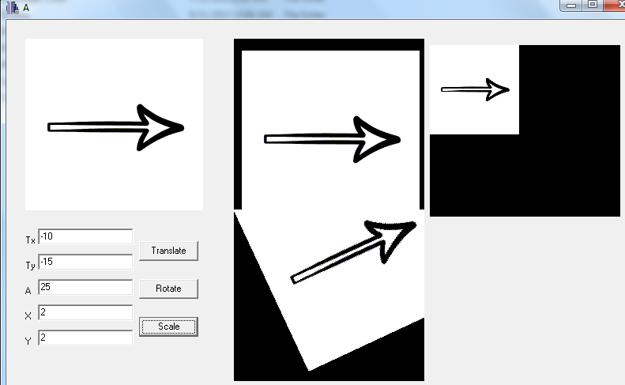

**CONCLUSION**

Hence, a program to translate, rotate and scale an image was implemented by using C++ with C++Builder.